# List Connection

## List Connection BOD Meeting Room HSBC

Tabel 1.1 List Hardware BOD Meeting Room HSBC V = Selesai , X = Belum Selesai

|  | Hardware | Port | From | To | Cable Type | Done | Pending |
| --- | --- | --- | --- | --- | --- | --- | --- |
| 1 | CISCO SX80 | HDMI OUTPUT | CODEC | TV RUANG 1 | HDMI EXISTING |  |  |
| 2 | CISCO SX80 | HDMI OUTPUT | CODEC | TV RUANG 2 | HDMI 15 m BARU |  |  |
| 3 | CISCO SX80 | MIC INPUT | CODEC | MEJA RUANG 1.A | AUDIO EXISTING |  |  |
| 4 | CISCO SX80 | MIC INPUT | CODEC | MEJA RUANG 1.B | AUDIO EXISTING |  |  |
| 5 | CISCO SX80 | MIC INPUT | CODEC | MEJA RUANG 2.A | UTP BARU |  |  |
| 6 | CISCO SX80 | MIC INPUT | CODEC | MEJA RUANG 2.B | UTP BARU |  |  |
| 7 | HD-MD4X2-4K-E | HDMI OUTPUT | HD-MD4X2-4K-E | CODEC SX80 | PATCHCORD HDMI BARU |  |  |
| 8 | HD-MD4X2-4K-E | HDMI OUTPUT | HD-MD4X2-4K-E | TV RUANG 2 | HDMI 15 M BARU |  |  |
| 9 | HD-MD4X2-4K-E | HDMI INPUT | HD-MD4X2-4K-E | MEJA RUANG 1 | HDMI 10 M BARU |  |  |
| 10 | HD-MD4X2-4K-E | HDMI INPUT | HD-MD4X2-4K-E | MEJA RUANG 2 | HDMI 15 M BARU |  |  |
| 11 | C2N-AMP-4X100 | RCA INPUT | CODEC SX80 | C2N-AMP-4X100 | UTP BARU |  |  |
| 12 | C2N-AMP-4X100 | SPEAKER OUTPUT | C2N-AMP-4X100 | SPEAKER | KABEL SPEAKER BARU |  |  |
| 13 | C2N-AMP-4X100 | SPEAKER OUTPUT | C2N-AMP-4X100 | SPEAKER | KABEL SPEAKER BARU |  |  |
| 14 | SWITCH | LAN | SWITCH | RMC 3 | UTP PATCHCORD BARU |  |  |
| 15 | SWITCH | LAN | SWITCH | TOUCHSCREEN | UTP EXISTING |  |  |
| 16 | SWITCH | LAN | SWITCH | CISCO SX80 | UTP EXISTING |  |  |

# Kebutuhan Power

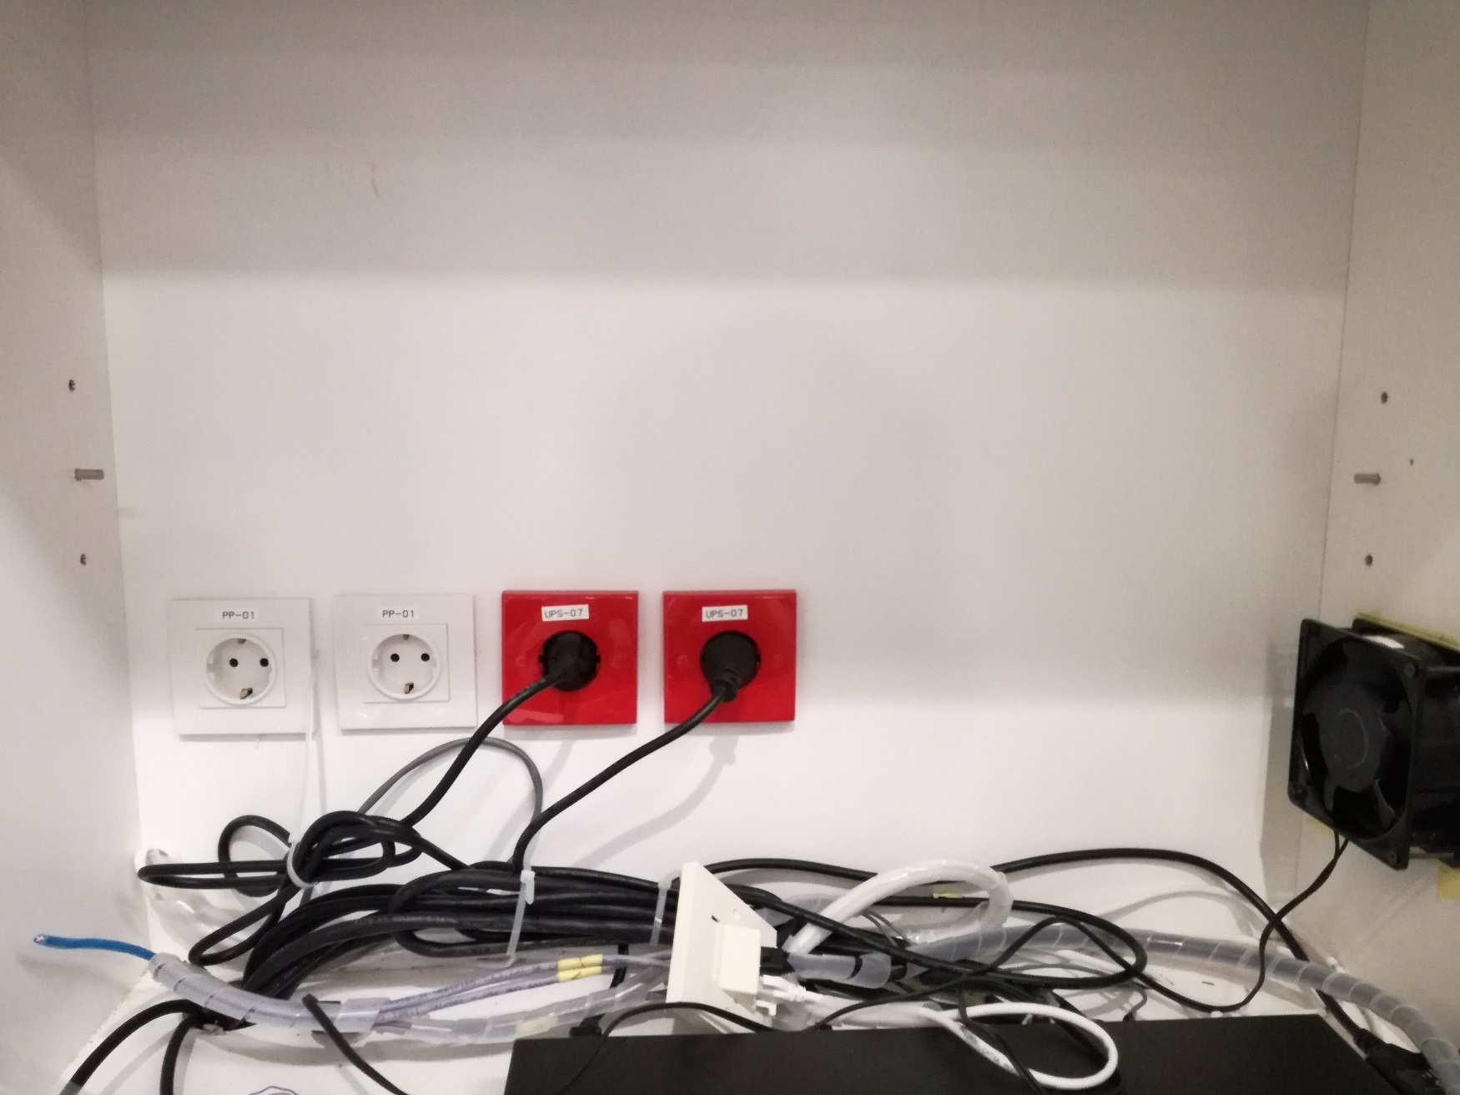

UPS

UPS

UPS

UPS

# List IP

## List IP BOD Meeting Room HSBC

Tabel 3.1 List IP BOD Meeting Room HSBC

| No | Hardware | IP Address Static |
| --- | --- | --- |
| 1 | RMC 3 | Not Available |
| 2 | TOUCHSCREEN 10” CISCO SX80 | Available |
| 3 | CODEC SX80 | Available |